You have 75 minutes (one class period) to complete this exam. Your answers must be recorded on this exam. This is a closed book, closed notes, (and closed neighbor) exam. You may ask the instructor questions but do not disturb your classmates. The Radford University Honor Code will be strictly enforced!

Questions 1-10 are short answer, fill in the blank, true/false and multiple choice. Each questions is worth 1 point.
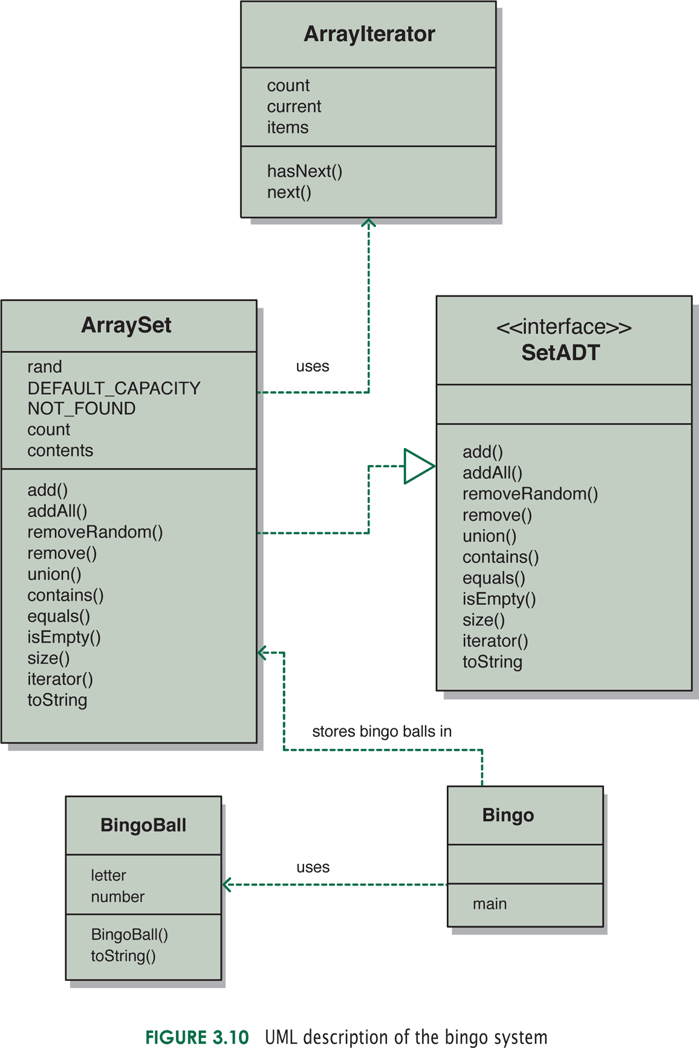

- BingoBall is a(n) ______________ while SetADT is a(n) ________________.

- equals(), iterator(), and size() are ______________.

- The relationship between Bingo and ArraySet is an example of ____________.
  - Uses
  - Aggregation
  - Inheritance
  - None of the above

- The relationship between ArraySet and SetADT is an example of ____________.
  - Association
  - Implements
  - Inheritance
  - Aggregation

- True or false, the stereotype <<interface>> means that SetADT is part of the user interface of this system.

- True or false, the instance data (attributes) listed in all capital letters represent constants.

- List the growth function below in descending order of time complexity.

f(n) = n³-1
g(n) = 7n² + 3n + 4000
h(n) = 300n*log(50n)
j(n) = (2^{n})/30

- What are the goals of Software engineering?
- Solve the right problem
- Deliver a solution on time and within budget
- Deliver a high-quality solution
- Accomplish these things in an ethical manner
- All the Above
- An object should be ______________, which means that the variables contained in an object should be modified only within the object.

- Draw the resulting stack at the end of the following operations:
  - x.push(new Integer (21) );
  - x.push(new Integer (9) );
  - Integer Y = X.pop();
  - x.push(new Integer (28) );
  - Integer Z = X.peek();
  - x.push(new Integer (22) );
  - Integer Y = X.pop();
  - x.push(new Integer (4) );

- (10 points) Assuming a class called Marina that has a field (instance data) named boats which is a two dimensional array (15 X 30) of boat objects, write a find method that will search the array for a given boat (target) and return a boolean indicating whether or not the give boat is in the Marina. You may assume that the boat class has an equals method that you may use to compare to the given boat.
boat[][] boats = new boat[15][30];
public boolean find (car target)
{

}
12. (10 points) The pop operation for our array implementation of a stack assumed that the bottom of the stack was at position 0 of the array. Re-write the pop operation assuming that the top of the stack is at position 0. Explain the consequences of this change to the time complexity of the operation. The original code for the pop operation is given below.
/**
* Removes the element at the top of this stack and returns a
* reference to it.
* @return element removed from top of stack
* @throws EmptyCollectionException if stack is empty
*/
public T pop() throws EmptyCollectionException
{
if (isEmpty())
throw new EmptyCollectionException("stack");

top--;
T result = stack[top];
stack[top] = null;

return result;
}

- (10 points) Complete the implementation of the toString method for the linked implementation of a stack. You may assume that objects stored in the stack also contain a toString method. Remember, the toString method does not print anything. It simply returns a String. This will require that you traverse the linked structure as we discussed in class.
/**
* Returns a string representation of this stack.
* @return String representation of this stack
*/
public String toString()
{
String result = "";
LinearNode current = top;

return result;
}

